MPPT BASED ON FUZZY LOGIC CONTROLLER (FLC) FOR PHOTOVOLTAIC (PV) SYSTEM IN SOLAR CAR
Seno Aji¹, Dwi Ajiatmo² Imam Robandi³, Heri Suryoatmojo⁴
^{1,3,4} Department of Electrical Engineering, Institut Teknologi Sepuluh Nopember (ITS)
Surabaya, 60111 Jawa Timur. Telephone. (031) 5947302
²Department of Electrical Engineering, Universitas Darul Ulum Jombang
Jombang, Jawa Timur. Telephone. (0321) 854106
E-mail: ¹ senoaji.eepis@gmail.com, ² ajiatmo@gmail.com ³robandi@ee.its.ac.id, ⁴suryoatmojo@ee.its.ac.id

Abstract
This paper presents a control called Maximum Power Point Tracking (MPPT) for photovoltaic (PV) system in a solar car. The main purpose of this system is to extracts PV power maximally while keeping small losses using a simple design of converter. Working principle of MPPT based fuzzy logic controller (MPPT-FLC) is to get desirable values of reference current and voltage. MPPT-FLC compares them with the values of the PV's actual current and voltage to control duty cycle value. Then the duty cycle value is used to adjust the angle of ignition switch (MOSFET gate) on the Boost converter. The proposed method was shown through a simulation performed using PSIM and MATLAB software. Simulation results show that the system is able to improve the PV power extraction efficiency significantly by approximately 98% of PV’s power.

Keywords: Maximum Power Point Tracking (MPPT), Photovoltaic (PV), Boost Converter, Fuzzy Logic Controller, Solar Car.

- INTRODUCTION
Consumption on fossil fuels as source of transportation energy has been predicted to increase along with population and economic growth in Indonesia. On the other hand, the depletion of fossil fuels, increasing emissions of pollutants and greenhouse gases become a serious problem in big cities. Nowadays, renewable energy becomes a solution to solve this problem in supplying the energy needs especially in the field of transportation. There are so many kinds of renewable energy that have been developed as sources of energy for transportation.
Indonesia is a tropical region and has availability of abundant solar energy. Among renewable energy sources, solar energy seems to be the most attractive energy source for electrical energy used by cars in Indonesia. The advantages of solar energy compared to fossil fuels because it is clean, pollution-free, and quiet/without sound. Conversion of solar energy into electrical energy requires a device called a photovoltaic (PV). Lately, PV has been produced in different types. Some commercial PVs have average efficiency varying with the highest efficiency value of 20 % [1]. Electricity provided by PV is the result of voltage and current in the same time. PV voltage and current depends on temperature and solar irradiation changes. Maximum Power Point Tracking (MPPT) is a technique to extract possible maximum power from the PV modules under all conditions of temperature and solar irradiation. MPPT has to use a good algorithm to find the MPP condition in a short time and also has a high efficiency. MPPT simulations have been investigated over the last few years and are summarized in [2-4]. Many conventional methods have been used for MPPT such as Perturb and Observe (P&O), fractional open-circuit voltage and incremental conductance. Conventional methods have slow responds and unsatisfactory. To resolved this problem and overcome non linearity of PV, an intelligent MPPT algorithms based on fuzzy logic controller (FLC) will be discussed in this paper.

- MATERIAL AND METHOD
- Electrical Car Powered by PV
Electric car (EC) powered by photovoltaic (PV) project is a joint research between the Institut Teknologi Sepuluh Nopember (ITS) Surabaya and SMK Muhammadiyah 7 Gondanglegi, Malang. This EC’s name is Suryawangsa. It uses brushless DC motor as its main propulsion and lead-acid batteries as its source of electricity. There are four PVs on the top the EC. Total maximum output power of the PV is 200 Watts.


2
3
4
5
6
1
Figure1. Electrical Vehicle Powered by PV [5]

Battery in addition is being used as a source of electrical energy storage or as energy storage generated by photovoltaic (PV). The electric car powered by PV is able to perform self-charging from sun energy. This car’s design and shape can be seen in Figure 1 [5].
In Figure 1, the whole car system consists of 6 blocks of diagrams. The first diagram is photovoltaic array. The second diagram is boost converter. The third diagram is battery. The fourth diagram is DC motor’s driver. The fifth diagram is speed/torque control system of DC motor. And the last diagram is monitoring system using serial communication. This paper focus on the battery charging powered by PV as shown by block diagram 1-3.

- Photovoltaic Model
PV model is described as a simple circuit consisting of a current source which is connected in parallel with a diode as shown in Figure 2.
Figure2. PV Model.

PV’s output power is depends on irradiation of sunlight and temperature received by PV cell’s surface [6]. PV has various types and models. Each PV module has different characteristics and efficiency.
In this work, the selected PV module is BELL 50WP whose specification is shown in table 1. This PV module was simulated using PSIM software in order to get the I-V (current-voltage) and P-V (power-voltage) curves. Simulation results are plotted in in figure 3 and figure 4. Figure 3 is the simulation results with different temperature and constant irradiation conditions, while figure 4 is the simulation results with different irradiation and constant temperature conditions.

Table1. Specifications of Solar Panel
Spesifications | Value
Manufacture | BELL Electronics
Standart Irradiance and Temperature | 1000 W/m², 25ºC
Maximum Power (P_{max}) | 50 W
Voltage @ P_{max} (V_{mp}) | 17.35 V
Current @ P_{max} (I_{mp}) | 2.88 A
Open-circuit Voltage (V_{oc}) | 21.88 V
Short-circuit Current (I_{sc}) | 3.08 A
Number of Cell | 24 cell
Tollerance Wattage | 5%
Weight module | 10 kg
Size module | 670cm*620cm*35 cm

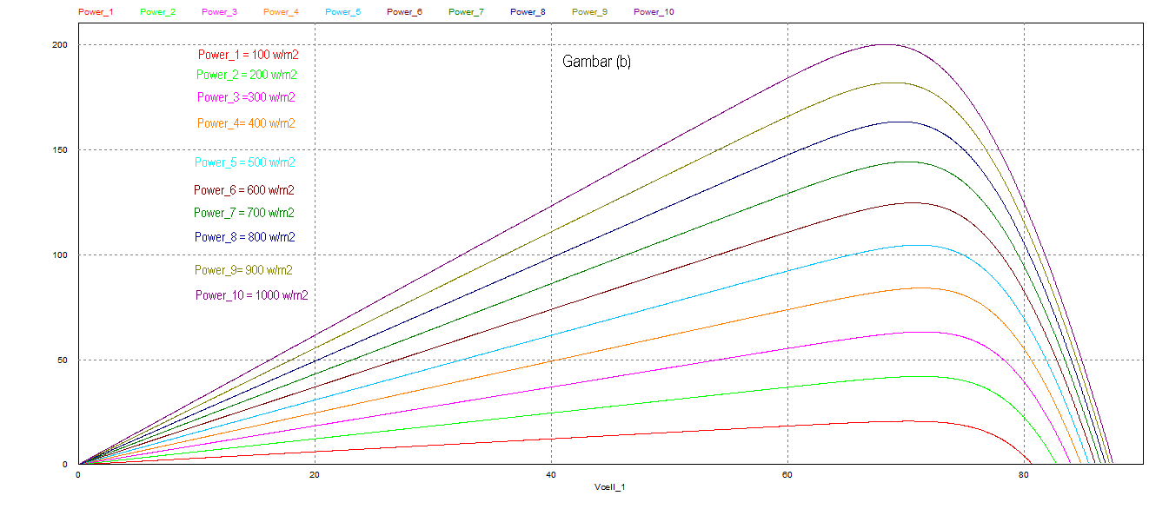
Figure 3 (a)

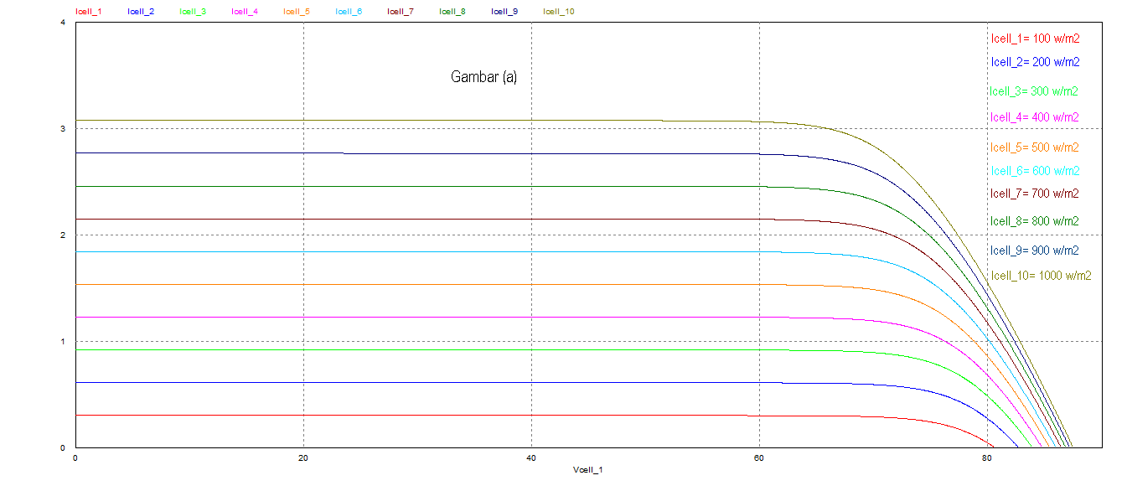
Figure 3 (b)

Figure 3 (b)

Figure3. Simulation result of different irradiance from 100 W/m² until 1000 W/m² (step 100 W/m²) and constant temperature at 25°C: (a) I-V Curve. (b) P-V Curve

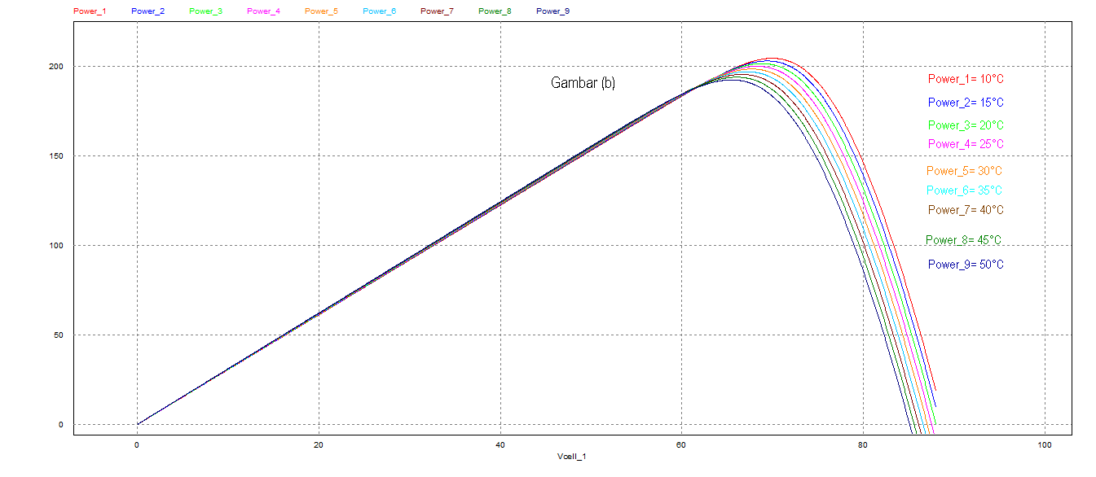
Figure 4 (a)

Figure 4 (a)

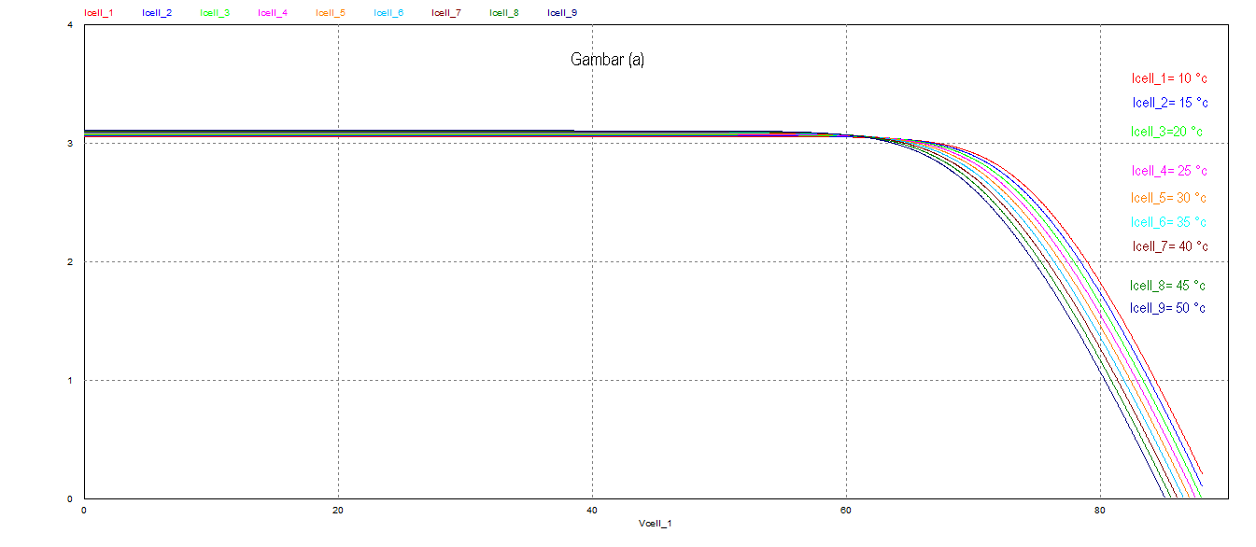
Figure 4 (a)

Figure 4 (a)

Figure4. Simulation Result of Different Temperature from 10°C until 50°C (step 5°C) and constant irradiance 1000 W/m². a) I-V Curve. b) P-V Curve.

- Boost Converter Design
DC-DC converter has an important role in the PV system. MPP conditions can be achieved by using DC-DC converter as a power conditioner. References [7-8] offer DC-DC converter topologies. In this paper the boost converter topology shown in Figure 5 is used [9]. It consists of a single MOSFET or IGBT switch, an inductor, a diode and a capacitor.
Figure 5. Boost Converter.

To design a good converter, it requires calculation of appropriate components since wrong values of the components may cause unfavorable outcomes. In the following is the parameter required for the design of boost converter [5]:
Input power (P): 200 Watt
Input voltage (V_{in)}: 34 Volt
Output voltage (V_{out}): 50 Volt
Switching frequency (f): 20 kHz

a. Calculation of duty cycle (D):
(1)
b. Calculation of load resistance (R):
(2)
c. Calculation of inductor’s current ():
(3)
d. Calculation of inductor (L):
(4) (4)
e. Calculation of capacitor (C_{min}):
Assumed: (5)
The calculated parameter values are listed in table 2.
Table2. Specification of Boost Converter
Parameter | Value
Capasitor (C) | 640 uF
Inductor (L) | 5.44 mH
Load Resistor (R) | 12.5 ohm
- Maximum Power Point Tracking (MPPT)
The basic method of MPPT controller is to find voltage reference (V_{MPP}) and current reference (I_{MPP}) under different conditions of solar irradiation and temperature by changing the value of load (R). Figure 6 shows characteristics of I-V (current-voltage) and P-V (power-voltage) curves. Working point (OPR₁) is the maximum power point (MPP) value in the condition insolation (λ₁), temperature (T₁) and load (R₁). If irradiation changes from λ₁ to λ₂ and temperature change from T₁ to T₂, the I-V curve shift from the curve (λ₁, T₁) to the curve (λ₂, T₂). Load condition should be changed from R₁ to R₂ to get MPP conditions (OP_{R2}).

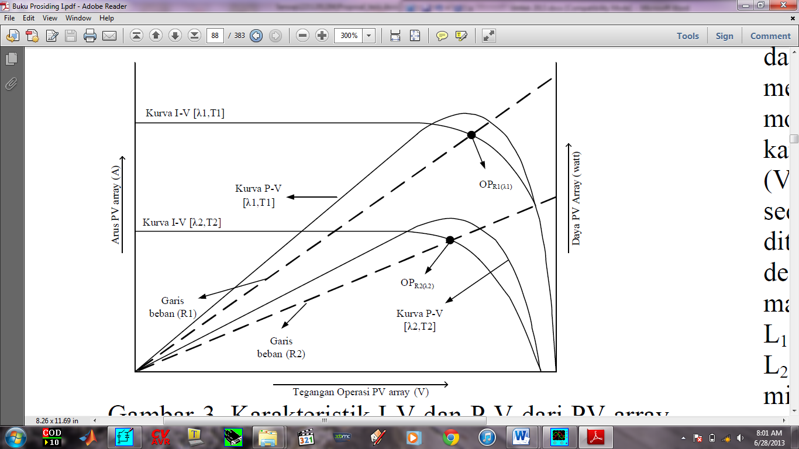
Current (A)
Voltage (V)
Power (Watt)
P-V Curve [λ₁, T₁]
OP_{R2 (λ2)}
OP_{R1 (λ1)}
Load (R₁)
Load (R₁)
Load (R₁)
P-V Curve [λ₂, T₂]
I-V Curve [λ₂, T₂]
I-V Curve [λ₁, T₁]

Figure 6. MPPT Curve.

- Fuzzy Logic Controller (FLC)
A fuzzy logic controller (FLC) uses two inputs such as error (E) and changes in error (∆E), while the output of FLC is the duty cycle D.
(6)
(7)
Designing a FLC involves four steps: fuzzification, interference, rule based, and defuzzification. Numerical input variables are converted into linguistic variables based on the membership function during fuzzification [10].
In operation of MPPT control, after E and ∆E are calculated, these inputs are converted into linguistic variables and then the output D is generated by looking up a rule-base table. The FLC tracks the MPP based on master rule of “If A and B, Then C” [10]. To determine the output of the fuzzy logic, the inference is used. There are many methods for inference but the popular one is Mamdani [10].

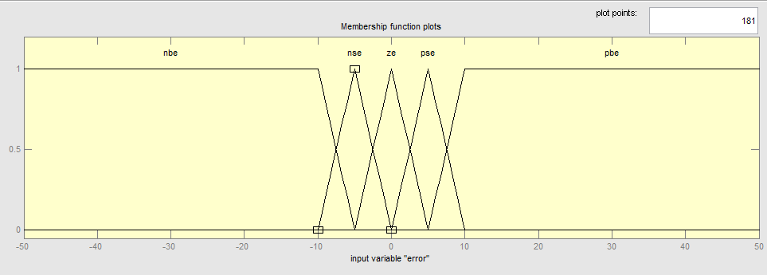

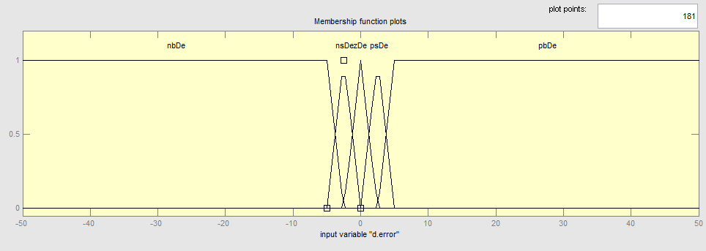

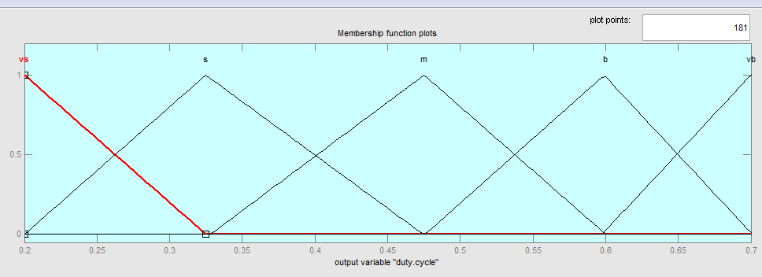

Figure 7. (a) Membership E_{(k)}, (b) Membership ∆E _{(k)} , (c) Membership Duty cycle

In this paper, fuzzy inference is carried using Mamdani’s type and the defuzzification use the center of grafity (COG) to compute the output of this FLC [11]. The result of this process is fuzzy rule, as seen in Table 3, and membership function of MPPT control, as seen at Figure 7.

Table3. Fuzzy Rule
E  ∆E | nbe | nse | ze | pse | pbe
nbDe | m | m | vb | vb | vb
nsDe | m | m | b | b | b
zeDe | b | m | m | m | s
psDe | s | s | s | m | m
pbDe | vs | vs | vs | m | m

- SIMULATION
Designing a PV model and a boost converter on PSIM is simpler than on MATLAB. The problem is that a fuzzy logic controller cannot be designed on PSIM. SIM Coupler in Figure 8

is a plug-in that could help to connect MATLAB Simulink with PSIM.
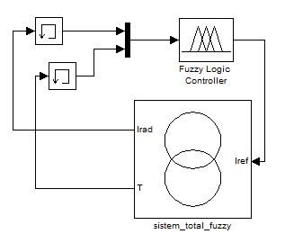
Figure 8. PSIM Coupler in Matlab Simulink
Figure 9. Block diagram of PV System

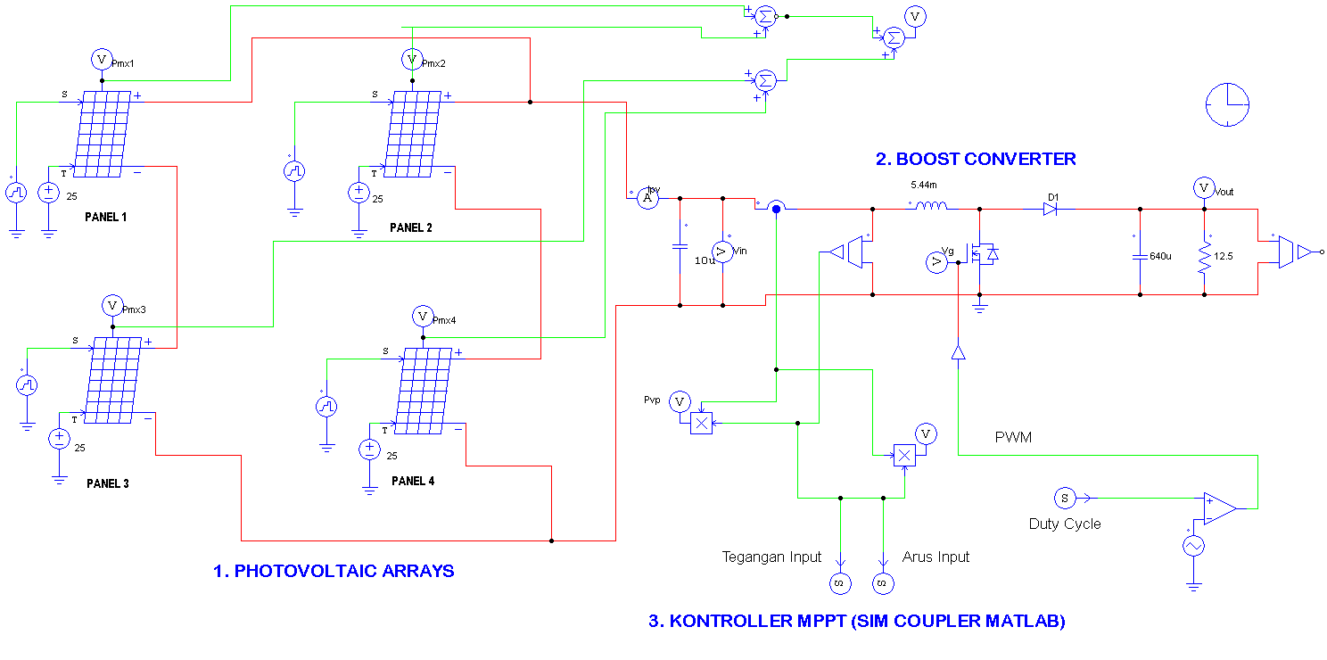
Input Voltage
into MATLAB
Input Current
into MATLAB

Duty Cycle from MATLAB

Pulse Width Modulation (PWM)
3. MPPT CONTROLLER
1. SOLAR PANEL/ PV
Figure10. Schematic of MPPT System in PSIM
Figure11. Schematic of MPPT in MATLAB

Block diagram of PV system is shown in Figure 9. It consists of PV array (yellow), boost converter (purple), MPPT based fuzzy logic controller/FLC algorithm (red) and the battery/load (blue). The MPPT algorithm (red) is explained in more detail in figure 10 and figure 11.
Simulation results in figure 3 and figure 4 show that the effect of irradiation changes is more significant than the effect of temperature changes in PV’s output power changes. Therefore, simulation was only done by changing the value of irradiation and keeping temperature constant.
Figure 12 shows simulation result of the PV system with MPPT. Figure 13 shows simulation result of the PV system without MPPT. The system was tested in irradiation 1000 W/m², 800 W/m², and 600 W/m². It shows that PV’s power output almost reached the maximum power (P_{max}).

Table3. Power output with MPPT (irradiation 800-1000 W/m² and temperature 25 º C)
Parameters | 1000 W/m² | 800 W/m² | 600 W/m²
P_{max} | 200 | 163 | 104
P_{pv} | 196 | 160 | 100
Efficiency | 98% | 98% | 96%

Table4. Power Output without MPPT (irradiation 800-1000 W/m² and temperature at 25 º C)
Parameters | 1000 W/m² | 800 W/m² | 600 W/m²
P_{max} | 200 | 163 | 104
P_{pv} | 190 | 139 | 54
Efficiency | 95% | 85% | 51%

From the results in table 3 and table 4, it is obvious that the system with MPPT gives higher efficiency than that without MPPT. It is concluded that the MPPT system could produce a maximum power output of PV eventhough under different (high/low) irradiation conditions.

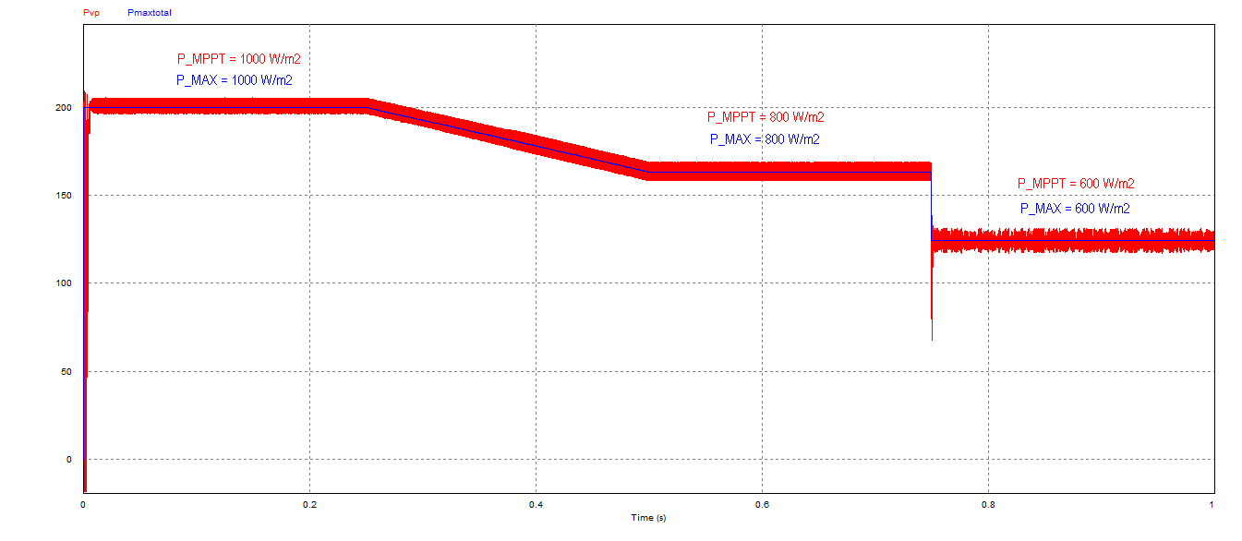
Figure12. Simulation Result with MPPT System
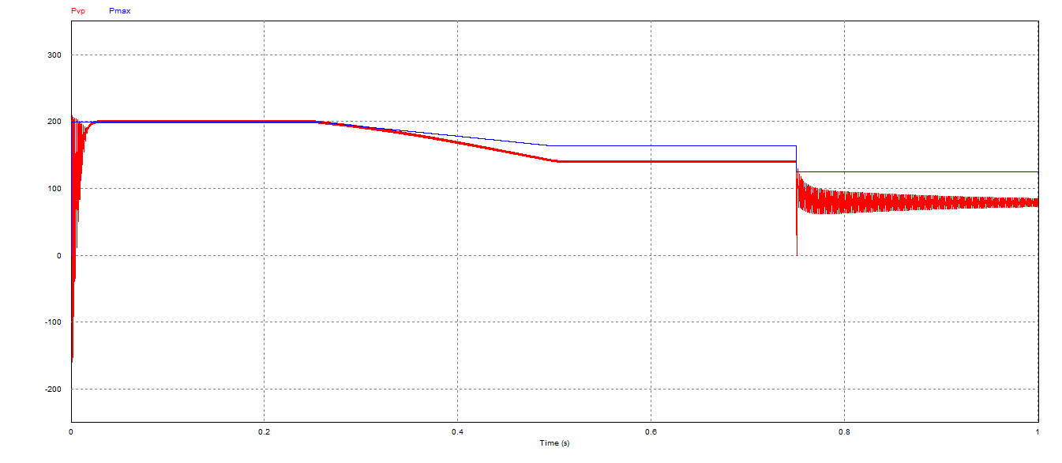
Figure13. Simulation Result without MPPT System

- CONCLUSION
In this paper we have presented the design and simulation of Maximum Power Point Tracking (MPPT) for a photovoltaic system in the solar car using fuzzy logic. Based on simulation results we can conclude that:
- The effect of irradiation changes is more significant than the effect of temperature changes in PV’s output power changes.
- The resulting efficiency value system with MPPT is 96 to 98% (almost reaches the maximum peak power), while the efficiency of the resulting system without MPPT is 51% to 90% (not producing maximum power).

ACKNOWLEDGMENT
Authors would like to thank to Vocational High School Muhammadiyah 7, Gondanglegi- Malang, Indonesia, and LPDP (Lembaga Pengelola Dana Pendidikan) for their supports in financial and facilities.

REFERENCE
- T. Markvart, L. Castaner, “Solar cells material, amufacture and operation,” Elsevier Science, Lt, ISBN-13: 978-1-85617-457-1, 2005.
- E. Bianconi, J. Calvente, and R. Giral, “Perturb and Observe MPPT algorithm with a current controller based on the sliding mode,” Science Direct: Electrical Power and Energy Systems 44 (2013) 346-356, July 2012.
- T. Esram and P.L. Chapman, “T-S Fuzzy Maximum Power Point Tracking Control of Solar Power Generation Systems,” IEEE: Transactions on Energy Conversion vol. 25, No 4, December 2010.
- C. B. Salah, M. Ouali, “Comparison of fuzzy logic and neural network in maximum power point tracker for PV systems,” Science Direct: Electric Power Systems Research 81 (2011) 43–50, July 2010.
- Senoaji, Muh. Taufiq, H. Suryoatmojo, Imam Robandi, “The Calculation of DC-DC Converter On Suryawangsa Solar Car,” Prosiding SENTIA 2013 - Politeknik Negeri Malang, Indonesia. Volume 5~ISSN:2085-2347. May. 2013
- Hong Wang, “The Stand-alone PV Generation System with Parallel Battery Charger”, 2010 International Conference on Electrical and Control Engineering (ICECE), pp. 4450-4453, June. 2010.
- M.A.A.Mohd Zainuri, M.A.Mohd Radzi, Azura Che Soh and N.Abdul Rahim, “Adaptive P&O-Fuzzy Control MPPT for PV Boost Dc-Dc Converter,” 2012 IEEE International Conference on power and Energy (PECon), 978-1-4673-5019-8, December 2012.
- L. Guo, J. Y. Hung, R. M. Nelms " Design of a fuzzy controller using variable structure approach for application to DC–DC converters," Science direct, Electric Power system Research 83 (2012) 104-109.
- J.M. Enrique, J.M. Andujar, and M.A. Bohorquez, “A reliable, fast and low cost maximum power point tracker for photovoltaic applications,” Solar Energy vol. 84, pp. 79-89, November 2009.
- Yeu Wu, Bia0biao Zhang, Jiabin Lu, K.L Du, “Fuzzy Logic and neuro-fuzzy system: A Systemetic Introduction”, International Journal of Artificial Intelligence and Expert System (IJAE) vol. 2, issue 2, pp 47-80, 2011.
- N. L Diaz, J. Hernandez “Fuzzy MPP Method Improved By A Short Circuit Current Estimator, Applied To A Grid-Connected PV System”, IEEE, pp. 978-1-4244-7463-9/2010.

