Perancangan Sistem Peredam Gangguan Vibrasi
Untuk Melindungi Beban-Guna Roket

Designing Vibration Disturbance Damping System
to Protect Payload of The Rocket
Sutisno and Andreas Prasetya Adi

Abstrak

Motor roket menimbulkan getaran yang menggetarkan seluruh roket beserta isinya. Bagian yang rentan mengalami gangguan adalah beban-guna roket. Beban-guna ini terdiri dari berbagai peralatan elektronik, transmitter, bermacam-macam sensor, akselerometer, gyro, dan sebagainya, termasuk embedded controller system. Pada makalah ini disajikan penelitian pengaruh getaran motor roket terhadap beban-guna, dan cara mengatasi atau mengurangi gangguan tersebut. Untuk mengatasi pengaruh gangguan getaran dapat dilakukan dengan menggunakan bahan silicon gel. Silicon gel dipilih sebagai bahan isolator karena memiliki faktor redaman spesifik yang relatif tinggi dibandingkan dengan beberapa bahan lain. Getaran motor roket disimulasikan menggunakan motor elektromagnetik, dan getaran diukur menggunakan sensor akselerometer. Hasil pengukuran ditampilkan dalam bentuk kurva, yang menunjukkan level getaran pada beberapa bagian benda uji. Hasil dari beberapa percobaan dapat digunakan untuk menentukan bahan peredam yang baik untuk dipakai guna mengurangi getaran yang mengganggu instrumen pada beban-guna.

Kata Kunci: motor, roket, energi, silikon.

Abstract

A rocket motor generates vibrations acting on whole rocket body including the content. Part of sensitive disturbance is the rocket payload. The payload consists of various electronic instruments, transmitter, various sensor, accelerometer, gyro etcetera, including the embedded controller system. The paper presents research of rocket vibration influence with respect to the payload, and the method to avoid or to minimize the disturbance. Avoiding vibration disturbance influence can be established using silicone gel material whose typical damping factors was relatively high. The rocket vibration is simulated using electromagnetic motor, and the vibrations are measured using accelerometer sensor. The measurement results were displayed in the form of curve, indicating the vibration level on some parts of the tested material. Some measurement results can be applied to determine the good material to attenuate vibration disturbing the instruments on the payload.

Keyword: motor, rocket, energy, silicone.

- Introduction
An important part in rocket is the electronic payload named embedded control system consisting of microprocessor, sensor, analog and digital circuits, transceiver radio, and wiring and power supply.
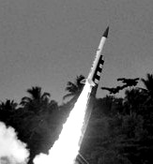
Figure 1. Rocket launching in burning time.

The whole parts of the payload must be protected from disturbances appearing mainly at the time of launching. The most influencing disturbances held along propellant burning time, as shown in Figure 1. At the time, very significant shocks and vibrations are held due to the rocket motor firing. Frequently problem appearing at the launching, the electronic parts of the payload were not functioned suddenly while motor was still fire. It happened mostly in launching of the big type ones such as RX-250, RX-320 and RX-420. To resolve the problem it needed dumping system to reduce vibration and shock disturbances. The dumping system can be used to protect the embedded system from various shocks, vibrations and acceleration forces, not only while burning time but so along whole rocket trajectory.

- Discussion And Theory
In rocket launching, signal disturbances able to damage the embedded control system consist of two components i.e. acceleration of vibration and linier acceleration yielded in motor thrust. In several Lapan rockets, linier acceleration reached up to 20 G. This value was smaller than acceleration of vibration valuing thousand G. According to that dominant disturbance constitute vibration the research presented in the paper is mainly focused to the disturbance caused by vibration.

- Vibration
Vibration which is defined as a magnitude (force, displacement, or acceleration) oscillating about a reference point is commonly expressed in terms of frequency, cycles per second or hertz (Hz).Vibration problems generally fall into two classes.
- Force excitation :
The isolator is used to protect the supporting structure from forces generated by the supported mass. An example is the use of motor mounts in an automobile
- Motion excitation :
The isolator is used to protect the supported mass from disturbances of the supporting structure. An example is the use of mounts under a coordinate measuring machine.

Natural Frequency is the frequency of vibration that will occur if a system is disturbed from its normal position and allowed to vibrate freely. For our purposes the natural frequency can be defined as a function of mass and stiffness or spring rate. If the spring rate is linear, the load vs. deflection curve is a straight line (Figure 2).
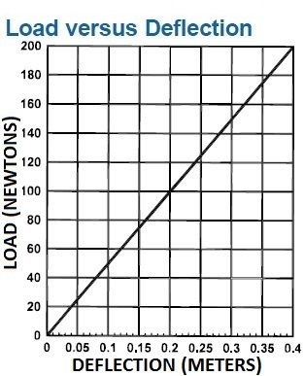
Figure 2. Load vs. deflection curve.

If we assume the supported item is a rigid body, the system will have a well-defined Natural Frequency (f_{n}).
$f_{n}=\frac{1}{2 π}\sqrt{\frac{K}{M}}$ (1)
Where
f_{n} : Natural frequency (hertz)
K : Stiffness (Newton per meter)
M : Mass of load (kilo gram)

If the frequency of the input that we are isolating from (the forcing frequency) is defined as f_{f}, it can be shown that if the spring has been selected so that:
$\frac{f_{f}}{f_{n}} > \sqrt{2}$ (2)
the displacement of the isolated item will be less than that of the input. This is the basis for vibration isolation (Figure 3). However, if :
$\frac{f_{f}}{f_{n}} < \sqrt{2}$ (3)
the displacement of the isolated item will be greater than that of the input. This is the region of amplification (Figure 3).
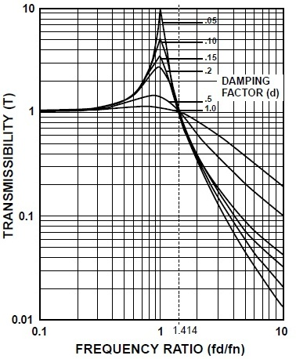
Figure 3. Typical transmissibility curves.

Since Transmissibility (T) is defined as the ratio of the output to the input: maximum transmissibility always occurs when the forcing frequency (f_{f}) and the natural frequency (f_{n}) coincide. This is commonly called the resonant point. If T is greater than one, amplification is occurring. If T is less than one, isolation is occurring.
Figure 3 depicts typical transmissibility curves for various damping conditions. Damping (d) is defined as the dissipation of energy by conversion to heat. Note that damping affects the magnitude of the response; it has little effect on the frequency of the response. Figure 4 gives damping factors for some typical materials.

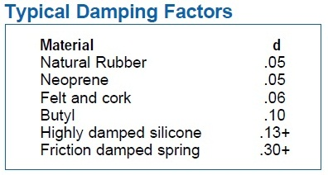
Figure 4. Typical damping factors.

Figure 3 indicates that while the maximum transmissibility varies with damping, for lower damping values the crossover point is always:
$$f_{n} \sqrt{2}$$
The three types of damping usually encountered are friction (Coulomb), hysteretic and viscous.
Friction damping is characterized by sliding surfaces. Hysteretic damping is the damping that is inherent in a material. Viscous (or fluid) damping is characterized by proportional relationships between forces and velocities, e.g. an object moving through a liquid. Transmissibility (T) is the ratio of the output to the input. If the input amplitude is 0.10 cm, and the output is 0.025 cm, the transmissibility will be:
$T = \frac{\text{output}}{\text{input}} = \frac{\text{.}\text{025}}{\text{.}\text{100}} = \text{.}\text{25}$ (4)
The percent of isolation can be expressed as:
% Isolation = (1-T) x 100
or in this case :
% Isolation = (1–.25) x 100 = 75%.
Quite often the magnitude of amplification at resonance is important. This point of maximum transmissibility is solely determined by the amount of damping (d) in the isolator. For isolators, d is typically .06 to .20. A simplified expression for maximum amplification (Q) for lower damping values is given by :
$Q = \frac{1}{2 d}$ (5)
If d = .13 (typical of a highly damped silicone)
$Q = \frac{1}{2 (\text{.}\text{13})} = 3\text{.}\text{85}$ (6)
The amplification factor at resonance for most isolators varies between 2.5 and 8.0.
While damping is desirable to control the response at resonance, it actually decreases the isolation at higher frequencies. As Figure 3 indicates, the more damping in a system, the less isolation at frequencies above $f_{n}\sqrt{2}$.
If the forcing frequency (f_{f}) and the desired transmissibility are known, the required system natural frequency is calculated by:
$f_{n} = \frac{f_{f}}{\sqrt{\frac{1}{T} + 1 }}$ (7)
Where
f_{n} : Natural frequency (hertz)
f_{f} : Forcing frequency (hertz)
T : Transmissibility (unity)
The natural frequency obtained and its harmonic have to be kept from interference.

- Shock
Shock is normally classified as a transient phenomenon in contrast to vibration that is normally a steady-state phenomenon. Shock isolation is considerably different from vibration isolation. A shock isolator is an energy storage device that stores the input energy by deflecting and then releasing that energy over a longer period of time. The energy is released at the natural frequency of the shock isolation system. Shock is normally defined by a pulse or a free-fall impact. Some typical pulse shapes are half-sine, triangular, rectangular and versed-sine. A convenient way to analyse shock problems is to use the velocity change method. The transmitted shock (G_{t}) is given by:
$G_{t} = \frac{V (f_{n})}{g}$ (7)
Where
G_{t} : Transmitted shock (unity)
V : Velocity (meter per second)
f_{n} : Natural frequency (hertz)
g : Acceleration due to gravity
(9.81m²/sec.)

The associated dynamic deflection (Δd) can be determined by:
Δd $= \frac{V}{2 π f_{n}}$ (8)
Where
Δd : Associated dynamic deflection
(meter)
V : Velocity (meter per second)
f_{n} : Natural frequency (hertz)

It is not very different between protecting the equipment in rocketing and in free-fall drop from a certain high. So far we have now found that to protect the equipment free-fall drop we need calculating :
- A system’s natural frequency,
- A dynamic deflection,
- A dynamic system stiffness.

All three of these conditions must be met to assure that no more than the acceleration value limit is transmitted to the equipment.
Note that the dynamic stiffness (K) found is the system stiffness. It must be divided by the number of mounts to determine the stiffness required per mount. If both vibration and shock are present, both must be considered. Quite often the final solution is a compromise.

- Vibration and Shock Problem in Rocket
Problem appearing in a rocket launching, mainly for the large diameter rocket having complex payload, is vibration and shock acting on whole rocket body. This uncontrolled force disturbs function of the embedded control system then can deflect the mission of the launching. In RX-320 rocket launching in 2009, the launching mission deflection was still existed. The payload functioned just for several seconds, while motor was still firing, then it was suddenly not functioned. It was not monopoly held in Lapan, but several foreign institute of aeronautics did so, even NASA did. The shock and vibration seriously disturbing their rockets was reported by NASA. Rocket vibration oscillates in the range from zero to 2000 Hz of frequency, and shock action beginning while motor starting until separation time valued 20 G.

- Damping Vibration and Shock
Damping vibration and shock can be established applying silicone gel material, as shown in Figure 5.
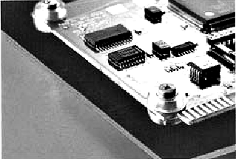
Figure 5. Silicone gel damping application.

The material was selected in line with the fact that silicone material having high typical damping factors, more than one of several other materials, as tabled in Figure 4. The same method and same material was so utilized in damping vibration and shock in the laptop to protect hard disk from vibration and shock while usage and while sudden falling down as shown in Figure 5.
Damping method established in rocket, applied metal spring combined with silicone gel. The spring was not made in spiral form to avoid unbalance while being loaded, as shown detail in Figure 6.
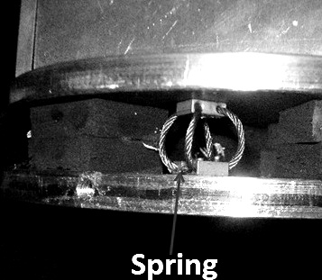
Figure 6. Spring damping application.

- Test And Observation

- Vibration Test
Testing installation was shown in Figure 7. The tests were done at BPPT (Puspiptek) Laboratory at Serpong.
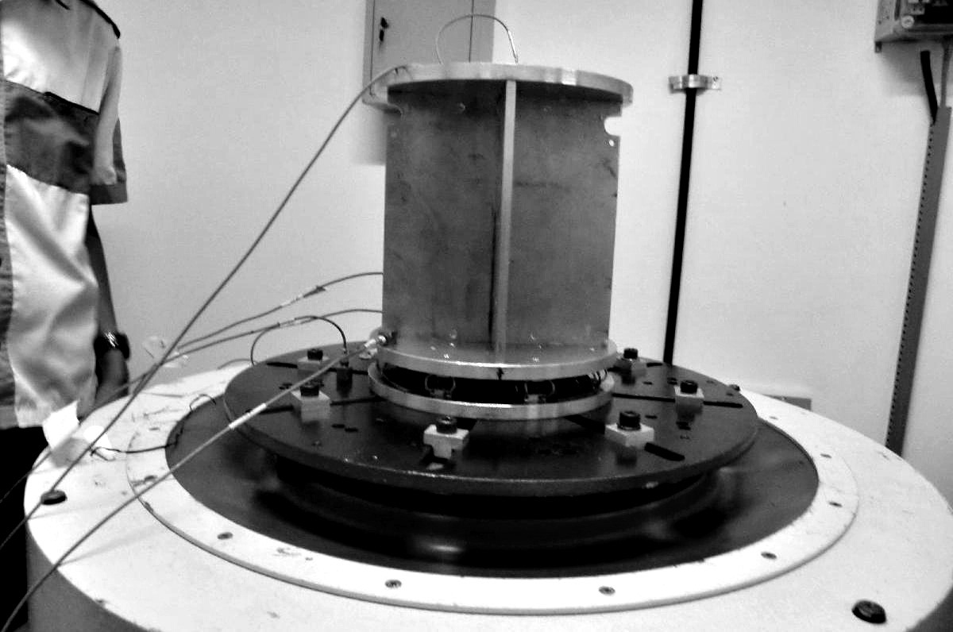
Figure 7. Vibration testing.

Compartment standard model of RX-200 rocket payload of 4.5 kg of mass, was damped using 8 CR2-200 types of Enidine damping, and PCB was covered in several materials of silicone, resulting curves shown in Figure 8. Acceleration was set in 1 G and signal disturbance was scanned 5 Hz - 2000 Hz of frequency

- Observation
In the curves of Figure 8, curve(1) shows vibration on the outer PCB box while curve(2) shows vibration on the surface of PCB covered by damping material. The two curves below them denote horizontal forward vibration being neglected, and do the other curves.
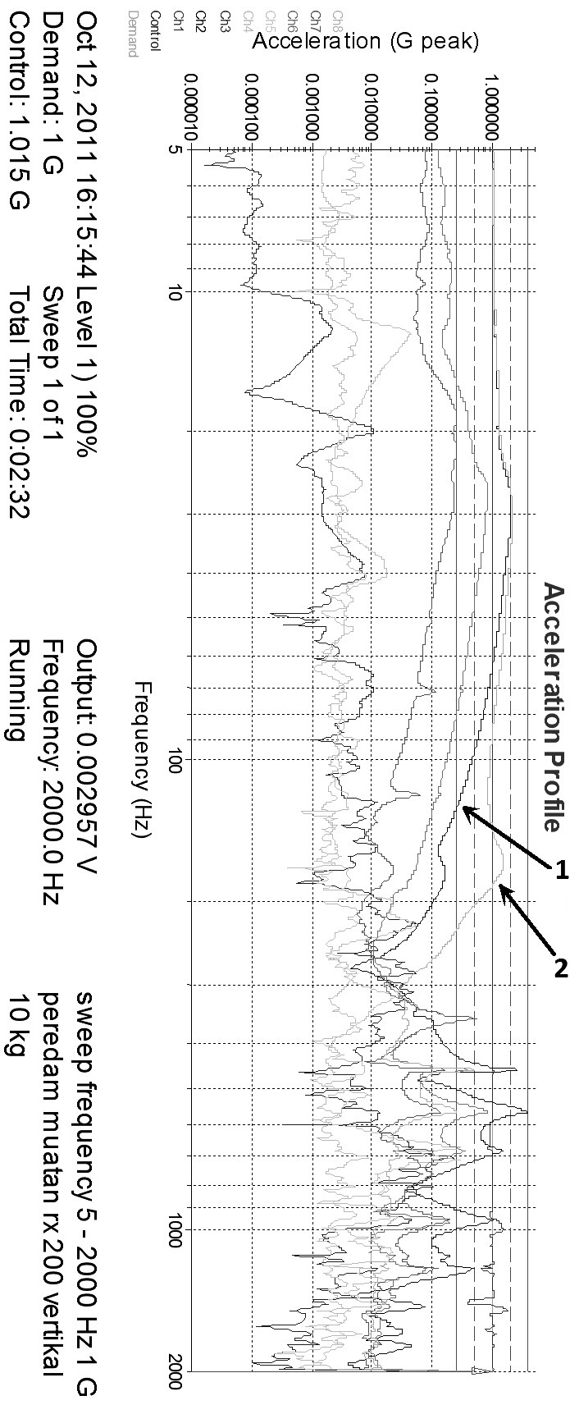
Figure 8. Amplitude vs. frequency curves
for some testing points.

It is seen that curve(1) and curve(2) have almost the same amplitude at low frequency (80 Hz). At medium frequency (80 Hz - 330 Hz), damped vibration amplitude are greater than one outer side (undamped). This phenomenon indicates appearing resonance between disturbance signals and dumping system having medium natural frequency. On the other hand, at high frequency (330 Hz - 2000 Hz), damped vibration amplitude are falling down under 0.1 G, smaller than signal disturbance amplitude. It means that the dumping system is relatively good enough and able to reduce 0.9 G of acceleration magnitude.

- Conclusion
According to the results of discussion, testing, and observation, conclusion can hbe got that the damping system designed is able to reduce the amplitude significantly. From equation (4), the transmissibility T will be 0.1 at 550 hertz of force frequency. Natural frequency of the damping system can be obtained from equation (7) :
$$f_{n} = \frac{\text{550}}{\sqrt{\frac{1}{0\text{.}1} + 1 }} = \text{166} \text{Hz}\text{.}$$
In fact the disturbance frequency measured is 1000 hertz. This value of frequency is higher enough than the natural frequency, and it is assuring not to interfere to the natural frequency of the damping system.

Daftar Pustaka
- Steinberg, Dave S, Vibration Analysis for Electronic Equipment, John Wiley & Sons, 2000.
- R. Caimi etal, Rocket Launch- Induced Vibration, NASA report.
- THE ASSOCIATED PRESS, New Rocket Has Problem With Vibration, The New York Times Published, January 20, 2008. http://spectrum.ieee.org.
- www.spacenews.com/civil/fix-for-ares-vibration-issue.html, NASA Identifies Fix for Ares 1 Vibration, 16 Sep 2009.
- Bingshang Li and Xinqi Xu, Coupled Vibration Analysis of Multiple Launch Rocket System by Finite Element Method, Computational Methods in Engineering & Science 2007, Part 10, 325.
- Agus Harno dkk, On-Board Fundamental Frequency Estimation of Rocket Flight Experiments Using DSP Microcontroller and Accelerometer, Jurnal Nasional Dirgantara, 2009.
- T. Srinivas Reddy etal, Design and analysis of vibration test bed fixtures for space launch vehicles, Indian Journal of Science and Technology, Vol. 3 No. 5, May 2010.
- Donghyun Hwang etal, Vibration Reduction module with Flexure Springs for Personal Tools, World Academy of Science, Engineering and Technology 56, 2009.
- Holter Warren G, Vibration reduction for electric motors, US patent 07/985,097, 1997.
- Shin, Sang-chul, Hard disk drive comprising flexible printed circuit with damping material," US patent 10/288507, 2002.
- Laporan Tahunan Bidang Kendali 2009.
- Advanced Vibration Components, Technical Section: Vibration and Shock Isolation, www.vibrationmounts.com.
- Enidine, Wire Rope Isolator Catalog, www.enidine.com.

